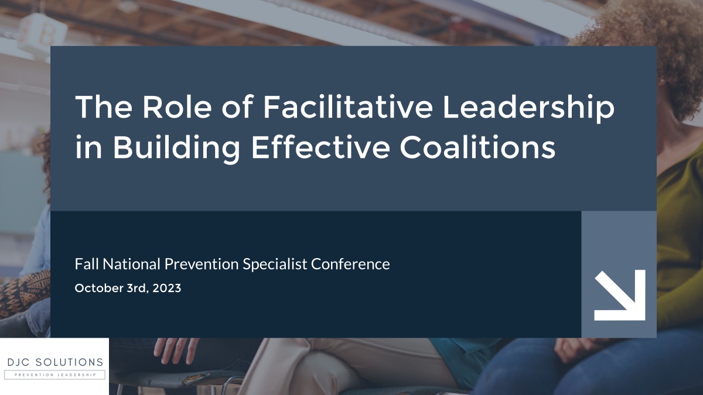

Table of Contents
Community Building 1
Facilitative Leadership Unpacked 2
Characteristics of Effective Facilitative Leaders 3
Facilitative Leadership Self-Assessment 5
Facilitating Coalition Development 6
Managing Conflict and Building Consensus 9
Strategies for Effective Collaboration and Coordination 11
Overcoming Challenges to Collaboration 11
The Collective Wisdom 12
Where do I get facilitation training? 13

DJC Solutions LLC, created by Dave Closson, is a modern-day consulting company that connects driven individuals and organizations to optimal performance. Dave takes his core teachings and principles and connects them to your individual situation... uplifting you in the moment and empowering you to pursue and achieve real change.

Dave works with professionals, organizations, veterans, and individuals looking to take their lives and careers to the next level. Dave’s dynamic, customized services include individual and group coaching, group facilitation, training, podcast network, course creation, and much more!

Learn more at https://www.daveclosson.com/

Community Building
One Word Check-In:
- Introduce yourself
- Share one word that represents your current thoughts, feelings, or expectations regarding being a prevention leader.

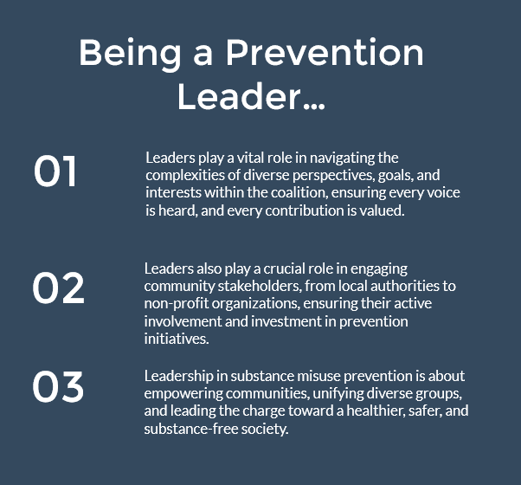
My thoughts on being a prevention leader:

Facilitative Leadership Unpacked
Facilitative Leadership is a leadership style that focuses on empowering and supporting others to achieve their goals and solve problems. It is about creating an inclusive environment where team members feel valued, heard, and motivated to contribute their best towards the objectives. The facilitative leader acts more as a guide or facilitator rather than a director or commander, helping the team navigate challenges and make decisions collaboratively.

1. Emphasis on Collaboration
Facilitative Leadership and Collaboration:
Facilitative leaders prioritize collaboration and collective decision-making. They believe in the power of diverse perspectives and skills, ensuring that every team member has an opportunity to contribute to discussions and decisions.

Example: In a community project, a facilitative leader would organize meetings where all stakeholders can express their views, concerns, and suggestions, ensuring that the final decisions are well-rounded and considerate of all aspects.

2. Empowering Team Members:
Facilitative Leadership and Empowerment:
Facilitative leaders empower team members by providing the tools, resources, and support needed to succeed. They encourage autonomy, allowing team members to take ownership of their roles and responsibilities.

Example: In a project, a facilitative leader might provide team members with training and resources to enhance their skills, boosting their confidence and capability to handle tasks effectively.

3. Problem-Solving Approach:
Facilitative Leadership and Problem-Solving:
Facilitative leaders adopt a problem-solving approach, guiding the team in identifying issues, exploring possible solutions, and choosing the most effective course of action together.

Example: Faced with a challenge, a facilitative leader would facilitate a brainstorming session, encouraging team members to think creatively and collaboratively to find innovative solutions.

4. Effective Communication:
Facilitative Leadership and Communication:
Clear and open communication is a hallmark of facilitative leadership. Leaders ensure that information is shared transparently, and feedback is exchanged constructively, fostering a culture of mutual respect and continuous learning.

Example: A facilitative leader would establish regular check-ins and feedback sessions, ensuring that everyone is on the same page and that any issues or concerns are addressed promptly.

5. Focus on Goals and Outcomes:
Facilitative Leadership and Goal Orientation:
While the approach is collaborative, facilitative leaders keep the team focused on goals and outcomes, ensuring that the collaborative efforts are channeled effectively towards achieving the objectives.

Example: A facilitative leader would help the team set clear, measurable goals and continuously monitor progress, ensuring that the team stays on track and achieves the desired outcomes.

Characteristics of Effective Facilitative Leaders
Emotional Intelligence is a cornerstone for effective facilitative leadership. Leaders with high emotional intelligence have the ability to perceive, understand, and manage not only their own emotions but also the emotions of others within their team or coalition. This acute awareness is pivotal for ensuring effective communication, adept conflict resolution, and robust relationship management within the group. By being attuned to the emotional undercurrents within the team, facilitative leaders can navigate conversations and situations with sensitivity and tact, ensuring that issues are addressed while maintaining the harmony and cohesion of the group. Their ability to manage emotions effectively contributes to a positive, supportive, and empathetic team environment, fostering stronger collaboration and mutual respect among members.

Active Listening and Clear Communication are other essential traits that facilitative leaders embody. Active listening involves paying undivided attention to others' words, asking clarifying questions, and restating information to ensure a comprehensive understanding of the communicated messages. This practice helps in making each team member feel heard and valued, promoting open communication and trust within the team.

Clear communication complements active listening by ensuring that leaders convey information, expectations, and feedback in a clear, transparent, and respectful manner. This clarity in communication ensures that every team member is aligned with the team's goals, roles, and expectations, minimizing confusion and maximizing efficiency and effectiveness in team operations. Together, active listening and clear communication form the bedrock for successful team interactions, collaboration, and goal achievement in facilitative leadership.

Problem-solving skills are paramount for facilitative leaders as they navigate the complexities of team dynamics and project challenges. These leaders excel in facilitating the process of identifying issues that the team or project may encounter. They create an environment where team members feel comfortable sharing their concerns and challenges openly. By leading brainstorming sessions, they harness the collective intelligence of the team to generate innovative and effective solutions. Their guidance in the decision-making process ensures that the chosen solutions are well-considered, practical, and aligned with the team's goals and objectives. This proactive and collaborative approach to problem-solving enhances the team's resilience, confidence, and effectiveness in overcoming obstacles and achieving success.

Empathy and adaptability further underscore the effectiveness of facilitative leaders. Empathetic leaders show genuine concern for their team members’ perspectives and well-being. This empathy translates into actions and decisions that consider the needs, preferences, and comfort of team members, fostering a supportive, inclusive, and respectful team environment. Team members feel valued and cared for, enhancing their engagement, satisfaction, and commitment to the team's success.

Adaptability in facilitative leaders ensures that they can swiftly and effectively adjust to changing circumstances, needs, and challenges. Their flexibility ensures that the team remains focused, aligned, and effective in achieving their goals despite any changes or uncertainties that may arise. This adaptability ensures the continuity, resilience, and success of the team in a dynamic and evolving context.

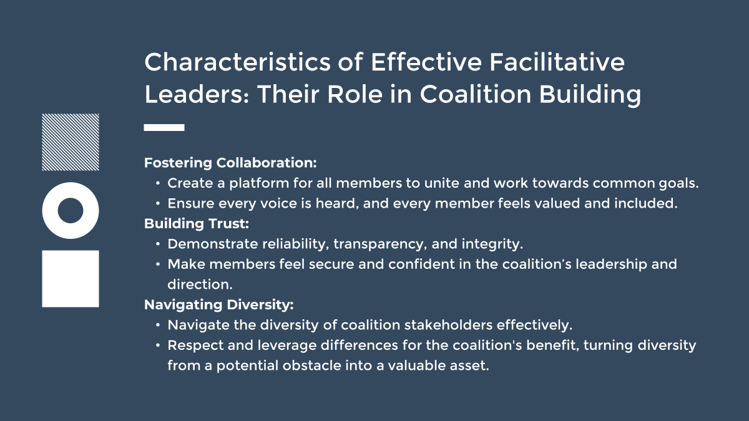

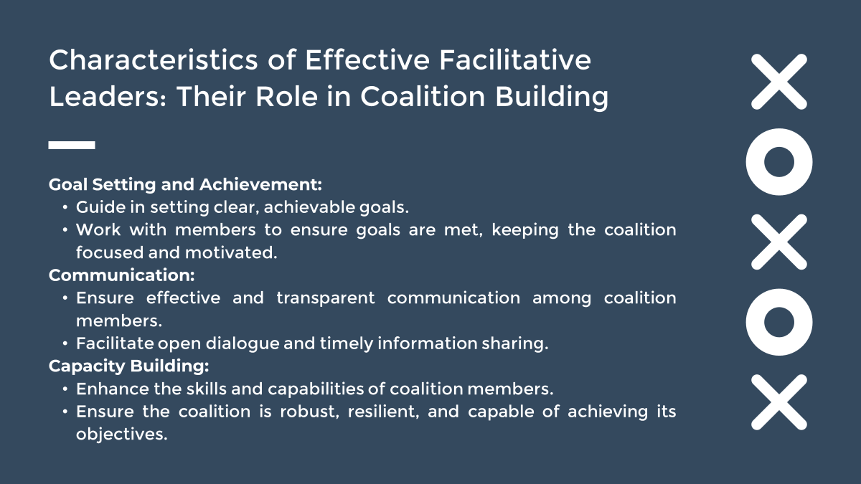

Facilitative Leadership Self-Assessment

Question | 1 (Not at all) to 5 (Very much so)
I am able to understand and manage my own emotions and those of others, ensuring effective communication, conflict resolution, and relationship management.
I pay careful attention to others' words, ask clarifying questions, and restate information to ensure understanding.
I convey information and expectations clearly, transparently, and respectfully, ensuring everyone is on the same page.
I facilitate the process of identifying issues and brainstorming solutions, guiding the team towards effective decision-making.
I show genuine concern for team members’ perspectives and well-being, fostering a supportive and inclusive environment.
I adjust to changing circumstances and needs, ensuring the team remains focused and effective in achieving their goals.
Total →

Total Score Ranges:
6-11: Emerging Leader
You are in the early stages of developing your facilitative leadership skills. Consider seeking additional training, mentorship, and opportunities to practice and enhance these essential leadership characteristics.

12-17: Developing Leader
You have a foundational understanding and capability in facilitative leadership. Continue to refine your skills, actively seek feedback, and implement strategies for improvement in specific areas.

18-23: Proficient Leader
You demonstrate strong facilitative leadership skills. Keep honing your abilities, staying adaptable, and ensuring you maintain a focus on continuous learning and growth.

24-29: Accomplished Leader
You exhibit excellent facilitative leadership skills. Continue to lead by example, mentor emerging leaders, and explore advanced leadership development opportunities.

30: Masterful Leader
You excel in all aspects of facilitative leadership. Continue to innovate, inspire, and contribute to the field of leadership, sharing your expertise and insights with others

Facilitating Coalition Development
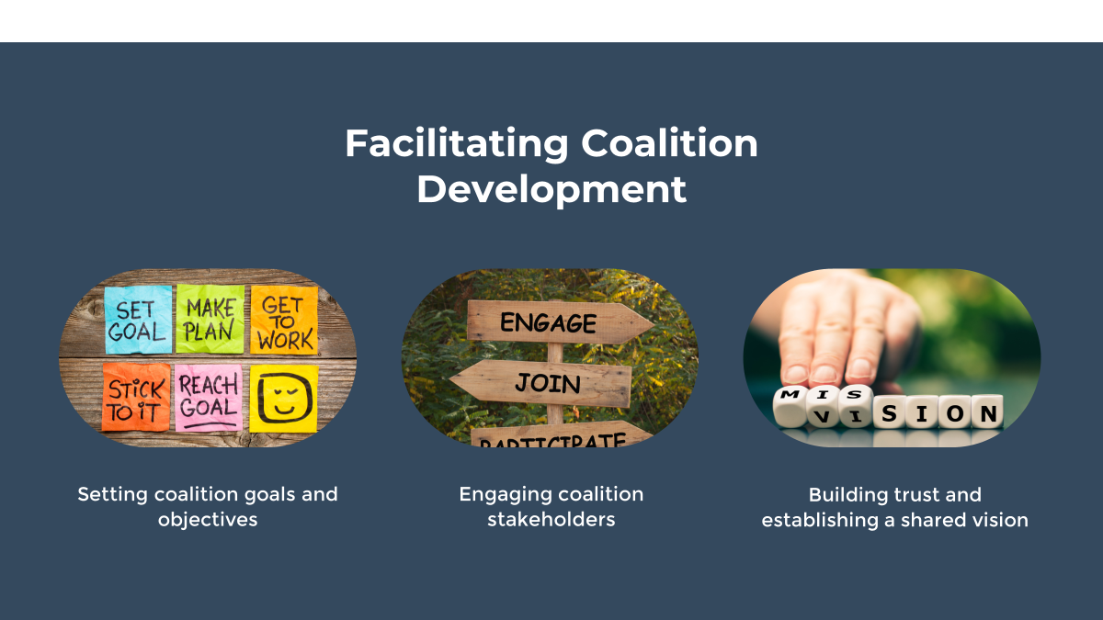

Setting Coalition Goals and Objectives
In contexts where traditional hierarchy is absent, and a group of community stakeholders come together, the role of setting clear and achievable goals becomes even more critical. In such settings, the power of choice and intrinsic motivation are the driving forces, and the clarity and alignment of goals play a pivotal role in harnessing these forces effectively.

Why It's Crucial:
In a non-hierarchical setting, individuals are bound together by a shared purpose rather than a formal structure. The clarity of goals provides a unified direction, ensuring that despite the diversity of stakeholders, everyone is moving towards the same destination. It helps in aligning the varied interests, perspectives, and contributions of stakeholders, ensuring cohesion and collaborative effort towards common objectives. Clear goals serve as the anchor, providing stability, focus, and a sense of shared purpose in the fluidity of a non-hierarchical environment.

How to Implement:
In such environments, the process of setting goals should be highly inclusive and participatory. Engage all stakeholders in collaborative goal-setting sessions, ensuring that every voice is heard, and every perspective is considered. Utilize facilitative leadership skills to navigate the diversity of views, finding common ground and building consensus around the goals and objectives. This inclusive approach not only enhances the relevance and alignment of the goals but also fosters a sense of ownership and commitment among stakeholders, enhancing their motivation to contribute actively towards the achievement of these goals.

Engaging Community Stakeholders
Engaging coalition members, especially in a non-hierarchical context, is a delicate and crucial task. The absence of formal authority structures means that engagement must be built on mutual respect, shared goals, and the intrinsic motivation of members. Below is an exploration of engaging coalition members in terms of Why, How, and What, especially in a context where traditional hierarchy or control is absent:

Why It's Crucial:
Engagement is the Fuel: In a coalition, engagement is the fuel that drives the engine of collaboration and achievement. Engaged members bring their energy, insights, and commitment to the table, enhancing the coalition's creativity, problem-solving capacity, and impact. They feel a sense of ownership and responsibility towards the coalition’s goals, contributing actively and meaningfully to its efforts.

How to Implement:
- Inclusive Decision Making: Ensure that all members have a voice in the coalition’s decisions, reinforcing their sense of value, ownership, and commitment. Use facilitative leadership techniques to create a space where every member feels heard, respected, and included.
- Clear Communication: Maintain transparent and open communication, keeping members informed, aligned, and connected. Ensure that members have access to all the information they need to contribute effectively to the coalition’s efforts.
- Recognition and Appreciation: Regularly acknowledge and appreciate the contributions of members, reinforcing their sense of accomplishment and value to the coalition.
- Provide Opportunities for Growth and Contribution: Offer opportunities for members to enhance their skills, knowledge, and capacities, and create platforms for them to contribute their strengths and expertise to the coalition’s efforts.

Building Trust and Establishing a Shared Vision
Why It's Crucial:
Foundation for Collaboration: Trust is the bedrock upon which successful collaboration is built. It fosters a safe and supportive environment where members feel comfortable sharing ideas, taking risks, and working together towards common goals.

Enhances Commitment: Trust strengthens members' commitment and loyalty to the coalition and its objectives, ensuring their active and sustained participation.

How to Implement:
- Consistency and Reliability: Demonstrate consistency and reliability in actions and decisions to establish trustworthiness.
- Open Communication: Maintain open, honest, and transparent communication, ensuring that members feel informed, heard, and respected.
- Acknowledge and Address Concerns: Promptly acknowledge and address members' concerns and issues, showing responsiveness and consideration.

Establishing a Shared Vision
Why It's Crucial:
Unifies the Coalition: A shared vision serves as a unifying force, aligning members’ efforts and ensuring cohesion and synergy in the coalition’s activities.

Provides Direction: It offers clear direction and purpose, guiding the coalition’s strategies, decisions, and actions.

How to Implement:
- Collaborative Vision Creation: Engage all members in the process of creating the shared vision, ensuring that it reflects the collective aspirations, values, and commitments of the coalition.
- Clear Articulation: Clearly articulate the shared vision, ensuring that all members understand and resonate with it.

Managing Conflict and Building Consensus
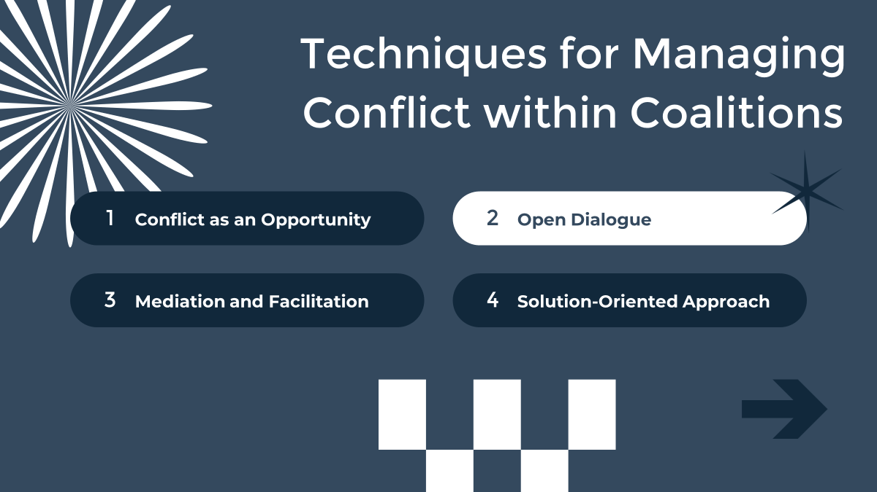

Importance of Collective Agreement:
Building consensus is fundamental in a coalition as it ensures that decisions made reflect the collective agreement and commitment of all members. It enhances the buy-in, ownership, and accountability of members, ensuring that decisions are not only supported but also effectively implemented. In the context of substance misuse prevention, consensus-building ensures that the diverse insights, experiences, and expertise within the coalition are harnessed in making decisions that are comprehensive, balanced, and impactful.

Inclusive Decision-Making Process:
Ensure that the decision-making process is inclusive, transparent, and participatory. All members should have the opportunity to contribute their insights, concerns, and suggestions, ensuring that decisions are informed, balanced, and reflective of the coalition’s diversity.

Clear Communication and Information Sharing:
Maintain clear, open, and transparent communication throughout the decision-making process. Ensure that all members have access to the information, discussions, and deliberations, enhancing their ability to contribute effectively to the decision-making process.

Facilitation and Guidance:
Utilize facilitation and guidance to navigate the decision-making process, ensuring that it remains focused, constructive, and aligned with the coalition’s objectives. Facilitators can help in guiding the discussion, managing differences, and ensuring that the process leads to a consensus that is supported by all members.

Practical Implementation:
In practice, building consensus involves active listening, empathy, and collaboration. Create platforms for dialogue, discussion, and deliberation, ensuring that all voices are heard, and all perspectives are considered. Employ strategies such as voting, negotiation, and compromise to navigate differences and reach a consensus.

Decision-Making Models:
Implement decision-making models that are collaborative and consensus-oriented, such as the Delphi Method or Nominal Group Technique. These models emphasize collective input, discussion, and agreement, ensuring that decisions are collaboratively made and widely supported.

The importance of active listening and effective communication
Foundation for Collaboration and Understanding:
Active listening and effective communication are the cornerstones of successful coalition building and management. They lay the foundation for mutual understanding, collaboration, and respect among coalition members. In the realm of substance misuse prevention, clear communication ensures that all members are aligned, informed, and engaged, enhancing the coalition’s cohesion, effectiveness, and impact.

Practices of Active Listening:
- Encourage and train members in the practices of active listening. This includes paying full attention to the speaker, avoiding interruptions, and seeking clarification for complete understanding. Active listening fosters a culture of respect, understanding, and empathy within the coalition.
- Transparent and Timely Communication: Ensure that communication within the coalition is clear, transparent, and timely. Utilize diverse communication platforms and strategies to ensure that all members are informed, connected, and engaged in the coalition’s activities, discussions, and decisions.
- Feedback and Adaptation: Create mechanisms for regular feedback and adaptation. Encourage members to share their insights, concerns, and suggestions, and ensure that the coalition responds constructively, adapting its strategies and actions based on members’ feedback.

Strategies for Effective Collaboration and Coordination
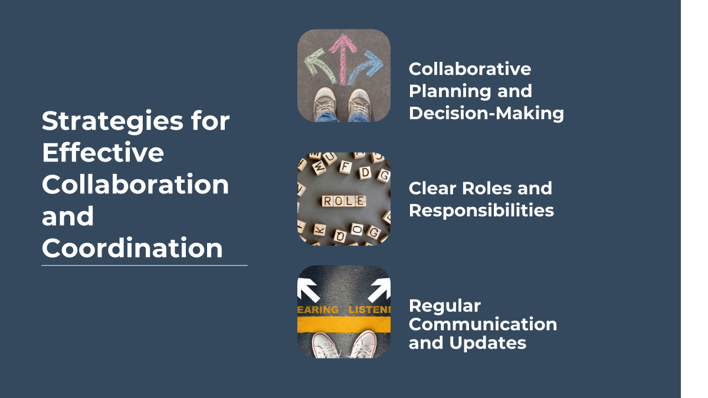

Overcoming Challenges to Collaboration
Identifying and Addressing Challenges:
Proactively identify and address challenges to collaboration within the coalition. Create a culture of openness and feedback, ensuring that members feel comfortable sharing their concerns, challenges, and suggestions for enhancing collaboration.

Training and Capacity Building:
Invest in training and capacity building to equip members with the skills, knowledge, and tools to collaborate effectively. Provide training on communication, conflict resolution, and team dynamics to enhance members’ ability to navigate challenges and collaborate effectively.

Flexible and Adaptive Approach:
Adopt a flexible and adaptive approach to collaboration, ensuring that the coalition can navigate changes, differences, and challenges effectively. Be open to revising strategies, roles, and approaches to enhance collaboration and overcome challenges.

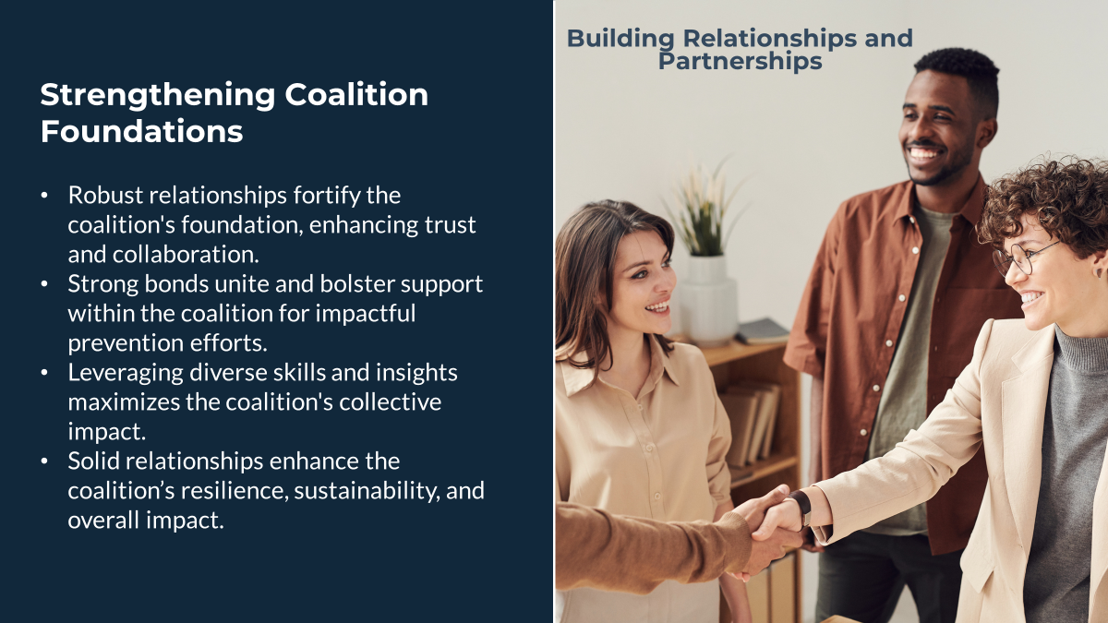

The Collective Wisdom
Link to shared Google Doc
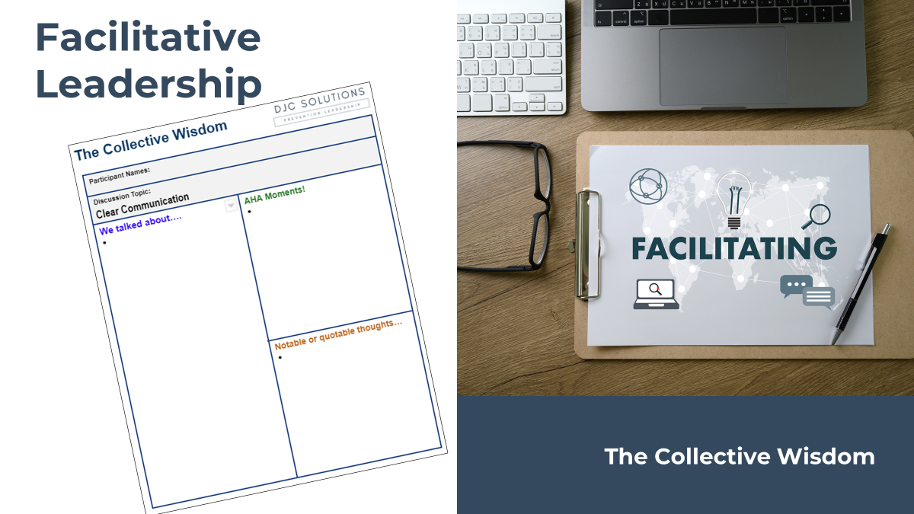

Where do I get facilitation training?
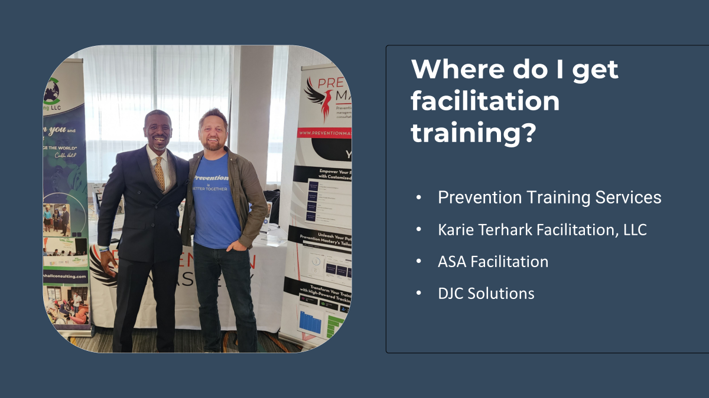



https://www.daveclosson.com/free-workbooks

